## **School Fee Payment and Receipt Management System**

### **1. Entity Relationship Diagram (ERD)**

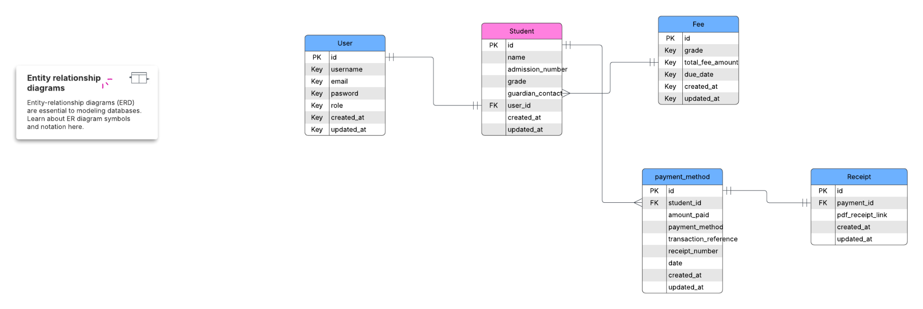

### **2. API Endpoints**

List all the API endpoints your backend will expose.

#### **Authentication Endpoints**

| **Endpoint** | **HTTP Method** | **Description** |
| --- | --- | --- |
| /api/auth/login/ | POST | User login |
| /api/auth/register/ | POST | Register a new user (admin, cashier, student) |

#### **Student Management**

| **Endpoint** | **HTTP Method** | **Description** |
| --- | --- | --- |
| /api/students/ | GET | List all students |
| /api/students/<id>/ | GET | Retrieve student details |
| /api/students/<id>/payments/ | GET | Get all payments for a student |

#### **Fee and Payment Management**

| **Endpoint** | **HTTP Method** | **Description** |
| --- | --- | --- |
| /api/payments/ | POST | Make a payment |
| /api/payments/<id>/ | GET | View payment details |
| /api/payments/<id>/receipt/ | GET | Generate and retrieve receipt |

#### **Fee Structure & Reports**

| **Endpoint** | **HTTP Method** | **Description** |
| --- | --- | --- |
| /api/fees/ | GET | View fee structure |
| /api/reports/summary/ | GET | View payment summary |